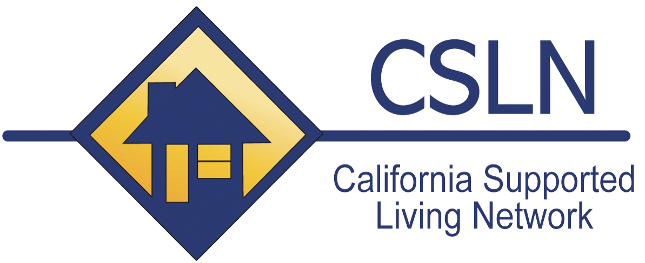

REQUEST FOR PROPOSAL

Application Due: November 30,2016
Direct any questions to bgallagher64@aol.com

California Supported Living Network is seeking proposal submissions for the 2016 CSLN Leadership conference, April 13-14, 2016 in San Diego, California. This year’s conference general theme is Honoring the Heart of the Matter: Realities & Opportunities. The annual conference is a platform to bring leaders in the field of community living together to discuss strategies that will improve the quality and strength of community living as an option for persons with developmental disabilities in the state of California.

Session Types:
The Keynote Address is presented in general session with the entire registry in one room. There is a Keynote Address that begins both mornings of the conference. The Keynote Addresses are scheduled for approximately an hour and a half.

Breakout Sessions are delivered in scheduled rooms throughout the day on both the 13th and 14th. Each session is 1 ¼ hours long.

While CSLN welcomes all topics related to community living, we are particularly interested in the following strands within this year’s theme of Honoring the Heart of the Matter: Realities & Opportunities.

- Leadership: information and/or strategies that help make our leaders and agencies stronger and foster sustainability.

- Community living and person centered thinking: information and/or strategies that are considered best practice and foster and culture of excellence.

- Human Resources: information and/or strategies that provide informed practices and improve the capacity of agencies to treat their employees fairly and positively.

If your presentation doesn’t match any of these themes, we encourage you to propose your theme as long as it fits within the framework of the CSLN belief statement:

- The Five Principles of Community Living are the foundation of all services.

- Small, medium and large agencies can provide quality services.

- The utilization of outside consultants creates positive influences and energy in an agency.

- It is essential to develop a strong learning culture within your agency.

- Self-monitoring through a QA process helps agencies stay centered on the values and principles they have committed to provide.

- It is the obligation of every agency to stay abreast of current laws, regulations and trends that effect the services they provide.

- It is crucial to maximize the utilization of natural and generic resources to promote cost effectiveness and diversity of supports.

- Agencies must commit to ethically and fiscally strong business practices that result in agency stability.

- It is the responsibility of every stakeholder to advocate for persons with disabilities and the systems that support them.

- It is the responsibility of all agencies to become contributing members of their larger communities through networking and collaboration.

Please complete this form and email to bgallagher64@aol.com by 11/30/16

PRESENTOR(S)

CONTACT INFORMATION (address, phone number, email)

WEBSITE:

TYPE OF PRESENTATION: KEYNOTE BREAKOUT

TITLE OF PRESENTATION

DESCRIPTION OF PRESENTATION

WHAT ARE THE MESSAGES OR TOOLS THAT PARTICIPANTS WOULD GAIN

